**Configuration Options for the Datasheet Generator**

In this document I would like to explain the options that we have right now

1. **If possible, do turn off the antivirus**

I understand for every person security and privacy is the main concern, how ever the software is connected to the online database the antivirus is detecting the .exe file as the malware/virus. If you are able to turn off the antivirus all the issues will be resolved

Usually, the desktop application is not detected as a malware but since we are using someone else database the security is compromised and the company/individual/database provider has the complete access to the database.

1. **Create an installer file**

I am not really confident about this option but since this is an easy step we can try this if you want. We will create an installer file for the software which will have an extension .msi through this you can install the complete software on your computer in a legal or you can say in a correct way, earlier I was sending you the developer (.exe) version of the software and If we try to install the software properly this might fix the issue.

I am not really confident about this option as the installer will create an exe file too at your desire location so there is a possibility that the antivirus will detect this as an malware but since this is an easy way we can try this option if you prefer.

1. **Hosting the software on cloud**

This will be the last but the best option in my opinion, we have to rent the cloud services form the provider to host our desktop application on it.

Let me explain how this is going to happen

1. First, we have to rent the cloud service form the provider like Google, Amazon, Azure etc, you can also rent the service of local provider but I will highly recommended **Google Cloud Platform** as this is really robust, and cheap as compare to other service provider, also there customer support is really friendly.
2. For 2 to 5 users, I think we should select the minimum option in terms of the system specification

I think a dual core processor + 4 GB Ram + 50 GB of SSD will work for us. Keep in mind that google cloud is really flexible so incase if you think the software is working slow, we will increase the number of core and the ram easily.

For this software will either use Windows Server 2008 or 2012

Note: 2008 version is not longer supported by google so we might use the newest version available

1. After getting the subscription google will give us an IP, username and password so that we can access the cloud

To access the cloud, we have to visit Remote Desktop Connection after entering the IP address it will ask the username and password and if the credentials are correct, you will be able to view the cloud platform.

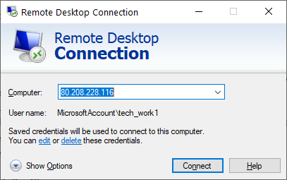

Do note that this is just a longer way to access the software once the rpd is created the software is really convenient to access, I will explain the rpd later in this document.

1. Once the subscription and the connection are done now It will be my turn to do the remaining part. First, I will install the database server on the cloud and then the software. It might take me a day to two for the installation and 2 to 3 days to make the changes to the existing software in order to make it work on the cloud.
2. Once everything is done anyone can log into the cloud to use the software using remote desktop connection (I have explained this in point no 3), also the interface of the cloud will be approximately the same as of the windows. But as for now only on user can access the software and when another user tries to login to the cloud the first user will be automatically log out form the server.
3. To enable the multi user we have to setup a rdp file this is not really complicated but since it is related to networking, I am not really good at that. Once the rdp file is setup, we will create separate account for each user, afterwards the user has to click on the rdp file and It will ask the username and password and once the credentials are correct it will directly show you the software without going to the cloud.

You can save the credentials as well to make a quick login.

You can read more info related to the rdp file here:

<https://fileinfo.com/extension/rdp>

**Advantages**

* Cloud services is always a good option as the complete software will be using cloud resources in order to run the software so you don’t need really high-end computer to run the software.
* Maintenance of the software will become a lot easier as I just have to update the cloud and the changes will be reflected to all the user immediately rather than sending the zip file to each user when the software is updated.
* The software will work fast as compare to the current version of software. The reason behind this is the local database instead of an online database (If you have any queries regarding this point, I can explain this in detail).
* There is always an option add or remove user to the cloud. You can add as many users you want and when you think the software is working slow just increase the resources of the cloud.
* Your data will be much secure as compare to now as you have created the own database server no other person have an access to it.
* No longer need for the subscription of online database.
* You can use the direct cloud on almost every platform like windows, Linux, MacOS, iPad, Android, iOS, etc. perhaps I am not really sure about the rpd.

**Disadvantages**

* Everything has its own drawbacks; the major issue will be the cost of the software since we are using cloud services. We have to pay monthly fee to the subscription provider like google.
* We have to find a person who will be able to setup the rdp file for us.

**Pricing**

Pricing is the main concern for every individual/ organization and I will try my best to save as much as I can in terms of cost.

In this document I have discuss the price of Google Cloud Platform, but you can take the estimate from other providers as well.

Google is offering 300$ free credit and I think it will be good enough for 3 to 4 months of use.

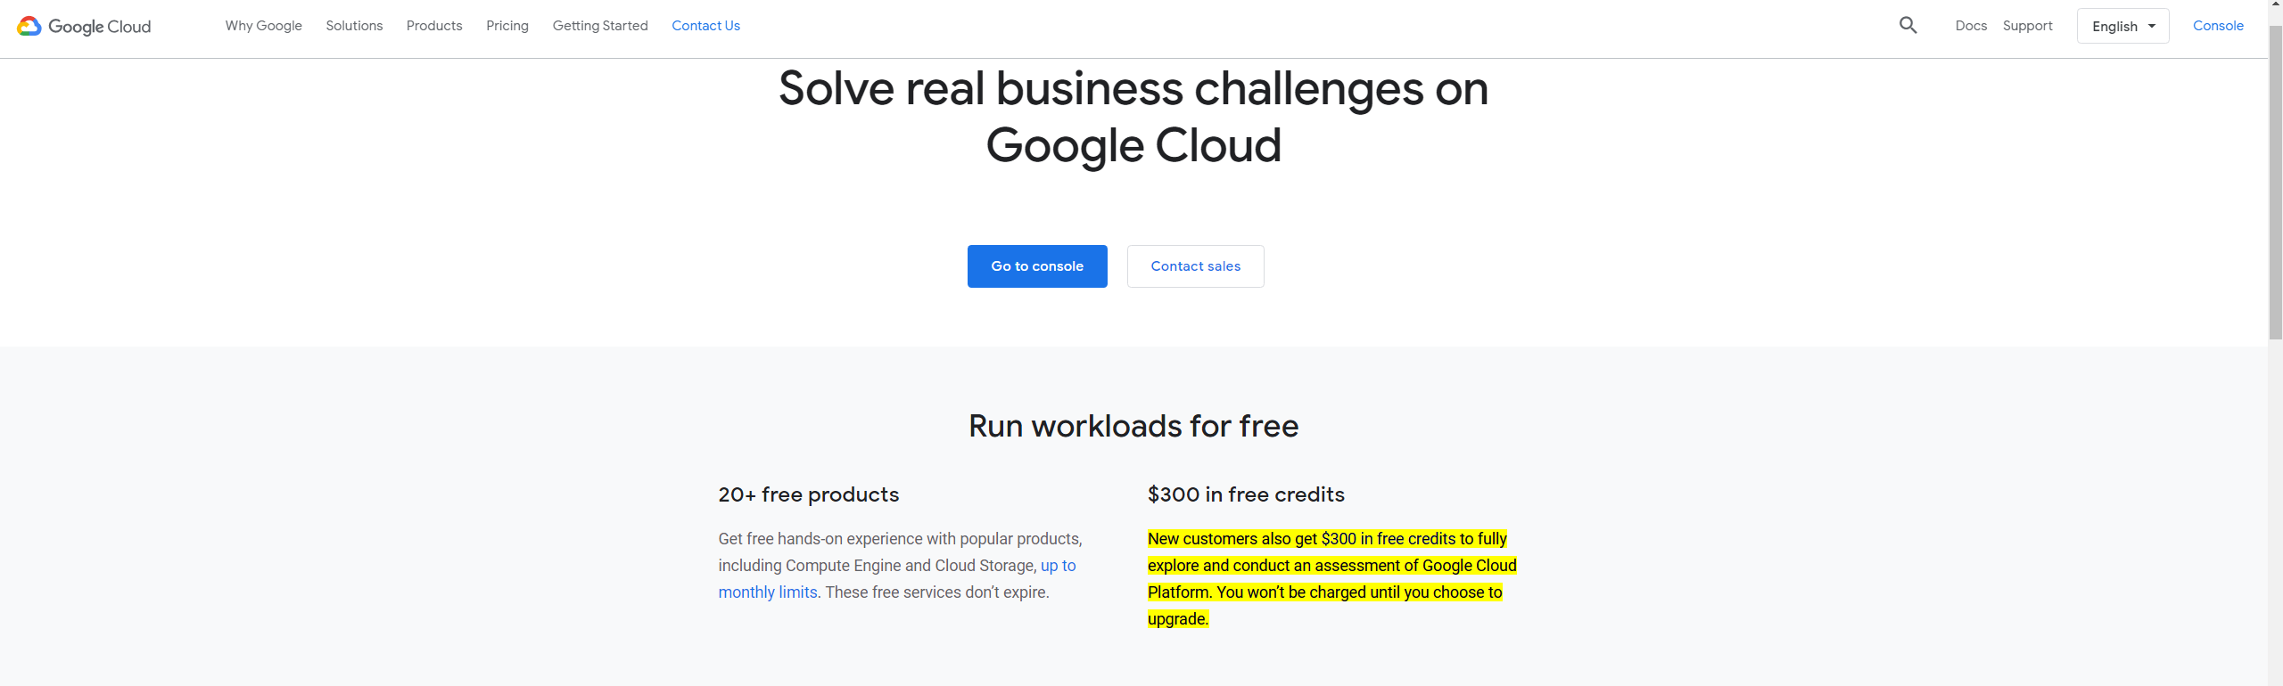

I have estimated google cloud price using their own price estimator tool

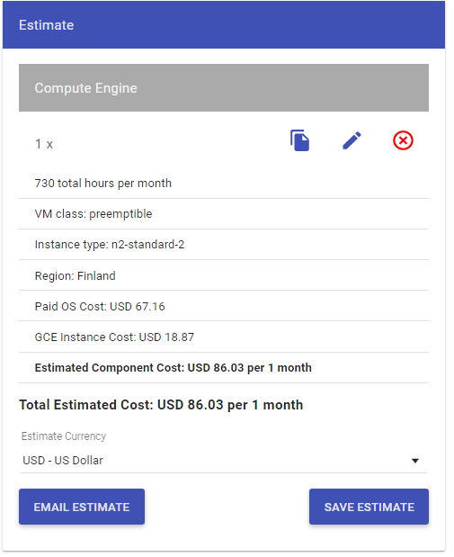

I have set all the parameters to max in terms to time, google charges are based upon the consumptions of the cloud in terms of time duration

In this estimate I told them that I will be using the cloud 24 x 7 which means the server will running throughout the week

We can reduce the cost as well if you turn off the cloud when it is not in use for example you can turn it off during the weekends

If you turn off the cloud on Saturday and Sunday the estimated price will be

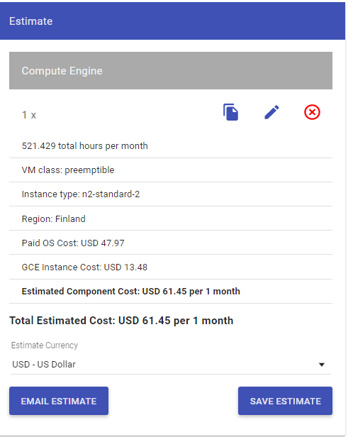

Also, there is a lot of cloud provider in the local market as well, which might be even cheaper

The selection of cloud is totally dependent upon you.